**PROJECT REPORT**

**ON**

**TRAVEL WEBSITE**

Project report submitted in partial fulfilment of the requirement for the award of the Degree of

Bachelor of Science

In

Computer Science and Cognitive Systems

**P KIRAN 111721036032**

**G EMMANUEL NISCHAY 111721036022**

**Department of Computer Science and Cognitive Systems**

**Loyola Academy**

(Autonomous and affiliated to Osmania University)

Re-accredited by “NAAC” with “A”

A “College with Potential for Excellence” by UGC.

Secunderabad

2023

**LOYOLA ACADEMY**

Old Alwal, Secunderabad – 500010

(An Autonomous Degree College affiliated to Osmania University)

Accredited by “NAAC” with “A” Grade

A “College with Potential for Excellence” by UGC.

Department of Computer Science and Cognitive Systems

**CERTIFICATE**

This is to certify that the project report entitled for **“BHAGYANAGARAM”** is a record of bonafide work carried out during 2nd Year, 2nd Semester as Partial fulfilment for the award of **DEGREE OF BACHELOR OF SCIENCE IN COMPUTER SCIENCE AND COGNITIVE SYSTEMS** during the academic year 2022-23.

The results embodied in this project report have not been submitted to any other University of any Degree or Diploma.

**NAME: P KIRAN and G EMMANUEL NISCHAY**

**CLASS: NCSC**

**UID: 111721036032 and 111721036022**

HEAD OF THE INTERNAL EXTERNAL PRINCIPAL

DEPARTMENT EXAMINER EXAMINER

**DECLARATION**

We hereby declare that the project entitled **“BHAGYANAGARAM”** done by **P KIRAN** (111721036032) and **G EMMANUEL NISCHAY** (111721036022) submitted to the HOD, **Mrs. A VARALAKSHMI** of the Department of Computer Science and Cognitive Systems, Loyola Academy UG PG College is a record of original work done by us.

The project has been successfully completed and submitted in partial fulfilment of the requirements for the award of “**DEGREE OF BACHELOR OF SCIENCE IN COMPUTER SCIENCE AND COGNITIVE SYSTEMS**” from “Loyola Academy UG PG College”, affiliated to “Osmania University, Hyderabad” in an authentic way and has not been submitted in any other university or institution for the award of degree or diploma.

**P KIRAN G EMMANUEL NISCHAY**

(111721036032) (111721036022)

**ACKNOWLEDGEMENT**

At the outset, I express my gratitude to the Almighty Lord for showering his grace and blessings upon me to complete this project.

Although our names appear on the cover of this book, many people had contributed in some form or the other to the development of this project. We could not do this project without the assistance or support of everyone, We Thank you all!

I wish to place on my record, our deep sense of gratitude to my Project Guide, **Mrs. A VARALAKSHMI** for their constant motivation and valuable help through the project work.

We also extend our thanks to other faculties for their cooperation during my course.

Finally, we would like to thank our friends for their cooperation to complete this project.

Yours Sincerely

P. KIRAN

G. EMMANUEL NISCHAY

**Loyola Academy**

(Autonomous and affiliated to Osmania University)

Re-accredited by “NAAC” with ‘A’ grade

A “College with Potential for Excellence” by UGC

**CERTIFICATE**

This is to certify that the following students have successfully completed the project titled **“BHAGYANAGARAM”** in Loyola Academy, Alwal.

|  |  |
| --- | --- |
| G. EMMANUEL NISCHAY  P. KIRAN | 111721036022  111721036032 |

They have done this project under the guidance and supervision of Mrs. A. Varalakshmi, HOD of B.Sc. Computer Science and Cognitive Systems, Loyola Academy. The project was completed to our satisfaction, and they showed keen interest and dedication to the project. The project duration is from December 2022 to April 2023. We place our appreciation on records for her best effort.

Mrs. A. Varalakshmi

B.Sc. Computer Science and Cognitive Systems (HOD)

Loyola Academy UG PG College

**INDEX**

1. Introduction
2. Abstract
3. Hardware and Software Requirements
4. System Analysis
5. System Design
   1. Use Case Diagram
   2. Sequence Diagram
   3. Activity Diagram
6. Implementation
   1. Code
7. Output
8. Conclusion
9. Future scope

**INTRODUCTION**

The term “Website” is a word we hear on a regular basis. Website means a collection of meaningful webpages that describe something in common about, what a website is actually about. Websites are used on a wide range for various applications. Websites are used for making e-commerce website, website for business purpose, website for personal use and so on. The main aim of using the website by various people is that, we can attract the users with colorful and organized information about the purpose we are actually using it.

The websites are build by using the following technologies:

* HTML
* CSS
* JAVASCRIPT
* BOOTSTRAP
* REACT
* DBMS
* PHP

Websites are also used by Travel Agencies, to show case their multiple tour details, upload destination details with HD images, availability of search options, tour booking services etc. Most of the people use these travel websites or travel agencies because everything at the tour can be taken care by the agency.

So, we are building a website to show case our city “HYDERABAD”. As we know Hyderabad is a popularly known city, where many visitors usually love to visit. To know about our beautiful city, we are going to share about our city details like historical places, parks, religious sites, famous food of Hyderabad, restaurants, trekking places and about Hyderabad. Along with that we are going to share the directions of the places with information, which we do not find in most of the websites.

**ABSTRACT**

The real importance of travelling comes from its nature and how it is defined. Beside of our daily hectic schedule and busy life, travelling can make a person’s mind calm and refreshes the mind to maintain a healthy mental health. As we know a good mental health has many benefits on physical body and positive mental thoughts. When a person becomes mentally stressed out to refresh his mind, travel can play a key role. Meditation and Yoga maybe helping a person to stay calm and focused but travelling also is a very good medicine, not only for our mindset but it involves us with understanding nature and surroundings.

We are having a lot of websites or tourism sites where they give information about various historical monuments in different countries, states and around the world. But the major drawbacks of these websites is that the information or the places which they put in are not completely available because they try to cover a lot of places in states or may be more than states. So, it does not mention the exact way we can travel to a particular place.

So, in our website we are not going to cover the places of a complete state but the travel spots of Hyderabad in such way that our website gives information enough to plan a day prior. Here, we are going to provide the information of each place in Hyderabad which makes the travelers more happy when they visit the place. The website is going to be in a neat structured format, which becomes easy for the website users to understand and plan accordingly.

**HARDWARE REQUIREMENTS**

* Operating System: Windows 8 or later
* Processor: Intel Pentium 4 or later
* Memory: 2GB minimum, 4 GB recommended
* Screen resolution: 1280 x 1024 or larger
* Application window size: 1024 x 680 or larger
* Internet connection: Required

**SOFTWARE REQUIREMENTS**

* Editor (VS Code)
* Web Browser
* Graphics Editor
* Xampp server

**SYSTEM ANALYSIS**

**Problem Definition:**

This project aims to show a detailed description about Hyderabad. The website which we are creating shows the historical places, parks, restaurants, trekking places, religious sites along with directions and a little bit of culture of Hyderabad. In many websites we do not find all the related information together. So, the main aim is to gather all the information together.

**SYSTEM DESIGN:**

System analysis for a travel website involves examining the requirements, designing the system architecture, and defining the specifications for the software components, data storage, and network infrastructure. The goal is to ensure that the website meets the functional and non-functional requirements of the business, and can be developed and maintained efficiently.

Some key steps in system analysis:

1. Gather information: Understand the goals, user needs, and functional requirements for the website. This may include features such as social media integration, content management, search functionality etc.
2. Define system architecture: Create the design for the website, including the hardware and software components that will be needed. This may include choosing a web development framework, identifying third party API’s and libraries that will be needed.
3. Develop detailed specification: Define detailed requirements of each component of the system. This will involve creating detailed diagrams, dataflow models etc.
4. Test and refine the system: Develop a testing plan to ensure that the system is reliable, secure and performant.
5. Deploy and maintain the system: Once the system has been fully tested, it can be deployed to a production environment and should be maintained and updated wisely.

Overall, system analysis for travel website is complex and iterative process. By following the best practices and by applying the latest tools and techniques, we can ensure that the website meets the needs of the user and provides a great user experience.

**UML DIAGRAMS**

* The Unified Modelling Language (UML) is a general-purpose development modelling language that provides a standard way to visualize system design.
* It is used to specify, visualize, modify, construct and document the components of an object-oriented software intensive system under development.
* UML combines the features of data modelling (via entity-relationship diagrams), business modelling (workflows), object modelling and component modelling.
* It can be used for any process, throughout the software development life cycle and across any implementation technology.

**TYPES OF UML DIAGRAMS**

There are several types of UML diagrams and each one of them serves a different purpose regardless of whether it is being designed before the implementation or after. The two broadest categories that encompass all other types are Behavioural UML diagram and Structural UML diagrams.

**Behavioural UML Diagram:**

* Activity Diagram
* Use Case Diagram
* Interaction Overview Diagram
* Timing Diagram
* State Machine Diagram
* Communication Diagram
* Sequence Diagram

**Structural UML Diagram**

* + Class Diagram
  + Object Diagram
  + Component Diagram
  + Composite Structure Diagram
  + Deployment Diagram
  + Package Diagram

**USE CASE DIAGRAM OF WEBSITE:**

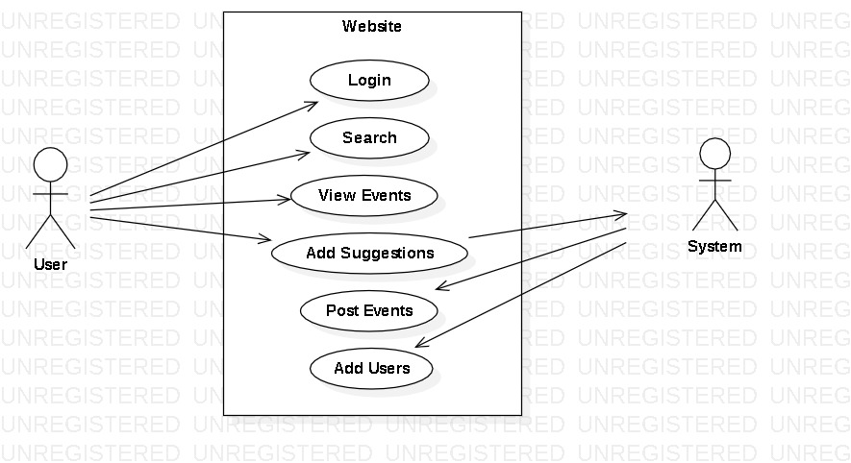

In this diagram, the main actors are the “User”, who is a person browsing the website, and the “System” or “Maintenance team”.

The main use cases for the User are ‘Browse site, which allows the user to navigate through the website and view products or content, and ‘Login’, which enables the user to sign up for an account with the website.

Once the User is logged in, they have access to additional use cases, such as ‘Search’ for finding specific content and ‘View information’, to see detailed information about a particular place.

The maintenance team regularly updates the website and takes the feedback of the users.

**SEQUENCE DIAGRAM OF WEBSITE:**

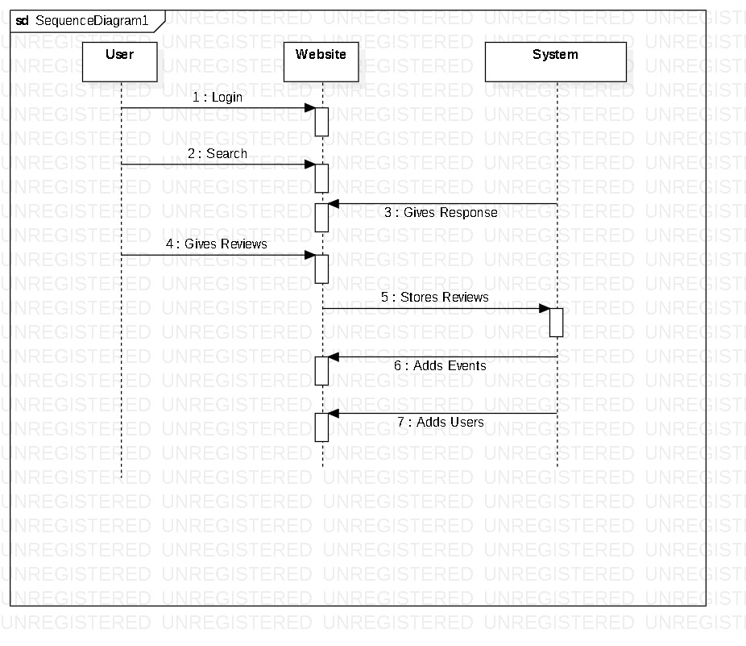

The above sequence diagram shows the following steps:

1. The user requests the website homepage.
2. The website displays the homepage to the user.
3. The user clicks login button.
4. The website displays the login form to the user.
5. The user enters their login credentials.
6. The website verifies the user’s login credentials.
7. The website redirects the user to the home page.
8. The website displays the page to the user.

**ACTIVITY DIAGRAM OF WEBSITE:**

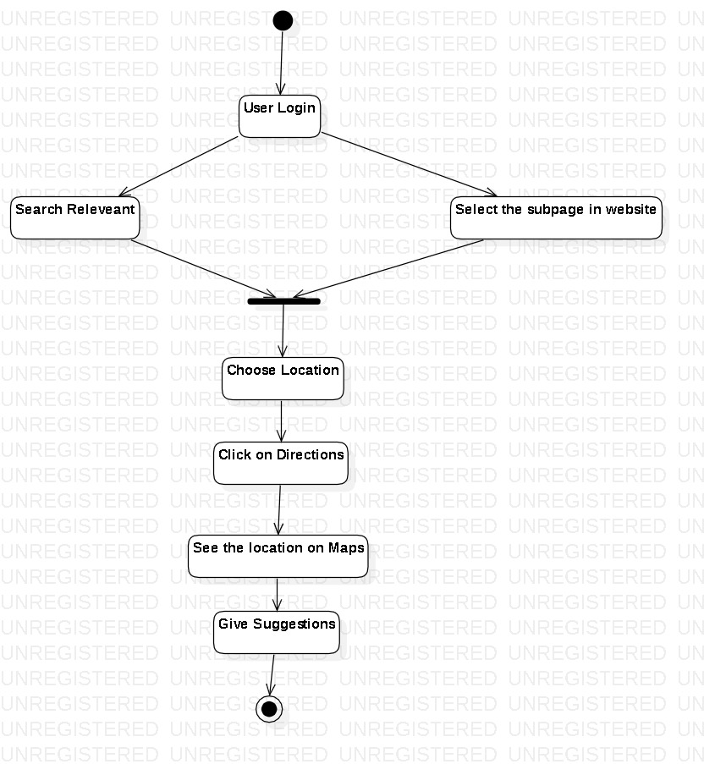

In this diagram, the user first interacts with website by loading the home page. They can then click on link to navigate to a relevant page, where they might perform some action, such as giving suggestion. Once the action is completed, it is processed and saved, and user can continue interacting with the website.

**IMPLEMENTATION OF A WEBSITE:**

1. When a user types in a domain name, the browser sends a request to the DNS to resolve the domain name to an IP address.
2. Once the IP address is obtained, the browser sends an HTTP request to the server hosting the website.
3. The web server receives the HTTP request and processes it. It retrieves the requested files and data.
4. The browser receives the files and processes them. It interprets the file to display the page layout and style, and executes the JS code to add dynamic functionality to the page.
5. Once all the resources are loaded, the browser renders the page and displays it to the user.
6. The user can then interact with the website by clicking on links, submitting suggestions and performing other actions. These interactions may trigger additional HTTP requests and server processing, leading to the website’s dynamic behaviour.

**CODE OF THE HOMEPAGE:**

<!DOCTYPE html>

<html lang="en">

<head>

<meta charset="UTF-8">

<meta http-equiv="X-UA-Compatible" content="IE=edge">

<meta name="viewport" content="width=device-width, initial-scale=1.0">

<title>BhagyaNagaram</title>

<!--font awesome link-->

<link rel="stylesheet" type="text/css" href="https://cdnjs.cloudflare.com/ajax/libs/font-awesome/6.3.0/css/all.min.css">

<!--custom css file-->

<link rel="stylesheet" href="C:\Users\Akshara\OneDrive\Desktop\folder\homestyle.css">

</head>

<body>

<!--home section starts here-->

<header>

<div id="menu-bar" class="fas fa-bars"></div>

<a href="https://www.peepultree.world/livehistoryindia/story/places/hyderabad-or-bhagyanagar" target="blank" class="logo"><span>B</span>hagyaNagaram</a>

<nav class="navbar">

<a href="#">home</a>

<a href="#box">about</a>

<a href="C:\Users\Akshara\OneDrive\Desktop\folder\trekking.html" target="blank">trekking</a>

<a href="C:\Users\Akshara\OneDrive\Desktop\folder\Religious Sites.html" target="blank">religious sites</a>

<a href="C:\Users\Akshara\OneDrive\Desktop\folder\parks.html" target="blank">parks</a>

<a href="C:\Users\Akshara\OneDrive\Desktop\folder\historical.html" target="blank">historical</a>

<a href="C:\Users\Akshara\OneDrive\Desktop\folder\restaurants.html" target="blank">restaurants</a>

</nav>

<div class="icons">

<i class="fa-sharp fa-solid fa-magnifying-glass" id="search-btn"></i>

<i class="fa-sharp fa-solid fa-user" id="login-btn"></i>

</div>

<form action="" class="search-bar-container">

<input type="search" id="search-bar" placeholder="search here...">

<label for="search-bar" class="fa-sharp fa-solid fa-magnifying-glass"></label>

</form>

</header>

<!--login form container starts-->

<div class="login-form-container">

<i class="fa-sharp fa-solid fa-xmark" id="form-close"></i>

<form action="">

<h3>login</h3>

<input type="email" class="box" placeholder="enter your email">

<input type="password" class="box" placeholder="enter your password">

<input type="submit" value="login now" class="btn">

<input type="checkbox" id="remember">

<label for="remember">remember me</label>

<p>forget password? <a href="#">click here</a></p>

<p>don't have an account? <a href="#">register now</a></p>

</form>

</div>

<!--login form container ends-->

<!--home section ends here-->

<!--video section starts-->

<section class="home" id="home">

<div class="content">

<h3>Hyderabad</h3>

<p>The city of dreams, the city of mystery, and the city that never sleeps.</p>

<a href="https://www.peepultree.world/livehistoryindia/story/places/hyderabad-or-bhagyanagar" target="blank" class="btn">discover more</a>

</div>

<div class="controls">

<span class="vid-btn active" data-src="C:\Users\Akshara\OneDrive\Desktop\folder\gallery\1.mp4"></span>

<span class="vid-btn" data-src="C:\Users\Akshara\OneDrive\Desktop\folder\gallery\2.mp4"></span>

<span class="vid-btn" data-src="C:\Users\Akshara\OneDrive\Desktop\folder\gallery\3.mp4"></span>

<span class="vid-btn" data-src="C:\Users\Akshara\OneDrive\Desktop\folder\gallery\4.mp4"></span>

</div>

<div class="video-container">

<video src="C:\Users\Akshara\OneDrive\Desktop\folder\gallery\1.mp4" id="video-slider" loop autoplay muted></video>

</div>

</section>

<!--video section ends-->

<br>

<!--gallery section starts-->

<section class="gallery" id="gallery">

<h1 class="heading">

<span>g</span>

<span>a</span>

<span>l</span>

<span>l</span>

<span>e</span>

<span>r</span>

<span>y</span>

</h1>

<div class="box-container">

<div class="box">

<img src="C:\Users\Akshara\OneDrive\Desktop\folder\historical\charminar.jpg" alt="charminar" width="474px" height="330px">

<div class="content">

<h3>charminar</h3>

<p>one of the ancient structure of hyderabad.</p>

<a href="https://www.hyderabadtourism.travel/historical-places-in-hyderabad" target="blank" class="btn">see more</a>

</div>

</div>

<div class="box">

<img src="C:\Users\Akshara\OneDrive\Desktop\folder\gallery\golconda.jpeg" alt="golconda">

<div class="content">

<h3>golconda</h3>

<p>one of the ancient structure of hyderabad.</p>

<a href="https://www.hyderabadtourism.travel/historical-places-in-hyderabad" target="blank" class="btn">see more</a>

</div>

</div>

<div class="box">

<img src="C:\Users\Akshara\OneDrive\Desktop\folder\historical\chowmahalla.jpg" alt="chowmahalla">

<div class="content">

<h3>chowmahalla palace</h3>

<p>it is one of the beautiful palace in hyderabad.</p>

<a href="https://www.hyderabadtourism.travel/historical-places-in-hyderabad" target="blank" class="btn">see more</a>

</div>

</div>

<div class="box">

<img src="C:\Users\Akshara\OneDrive\Desktop\folder\gallery\biryani.jpeg" alt="biryani" width="474px" height="330px">

<div class="content">

<h3>biryani</h3>

<p>it is one of the loved item of hyderabad.</p>

<a href="C:\Users\Akshara\OneDrive\Desktop\folder\restaurants.html" target="blank" class="btn">see more</a>

</div>

</div>

<div class="box">

<img src="C:\Users\Akshara\OneDrive\Desktop\folder\gallery\haleem.jpeg" alt="haleem" width="474px" height="330px">

<div class="content">

<h3>haleem</h3>

<p>it is one of the seasonal dish of hyderabad.</p>

<a href="C:\Users\Akshara\OneDrive\Desktop\folder\restaurants.html" target="blank" class="btn">see more</a>

</div>

</div>

<div class="box">

<img src="C:\Users\Akshara\OneDrive\Desktop\folder\gallery\sweet.jpeg" alt="sweet" width="474px" height="330px">

<div class="content">

<h3>sweet</h3>

<p>double-ka-meta is considered as favorite sweet.</p>

<a href="C:\Users\Akshara\OneDrive\Desktop\folder\restaurants.html" target="blank" class="btn">see more</a>

</div>

</div>

<div class="box">

<img src="C:\Users\Akshara\OneDrive\Desktop\folder\gallery\bathukama.jpeg" alt="bathukama" width="474px" height="330px">

<div class="content">

<h3>bathukamma</h3>

<p>the most loved festival of hyderabad.</p>

<a href="https://bathukamma.telangana.gov.in/about-bathukamma" target="blank" class="btn">know more</a>

</div>

</div>

<div class="box"

<img src="C:\Users\Akshara\OneDrive\Desktop\folder\gallery\pothraj.jpeg" alt="pothraj" width="474px" height="330px">

<div class="content">

<h3>festival</h3>

<p>one of the joyful festival of hyderabad.</p>

<a href="https://hyderabad.telangana.gov.in/festival/bonalu/" target="blank" class="btn">know more</a>

</div>

</div>

</div>

</section>

<!--gallery section starts-->

<br>

<!--contact starts-->

<section class="contact">

<h1 class="heading">

<span>c</span>

<span>o</span>

<span>n</span>

<span>t</span>

<span>a</span>

<span>c</span>

<span>t</span>

</h1>

<div class="row">

<div class="image">

<img src="C:\Users\Akshara\OneDrive\Desktop\folder\gallery\contactus.jpg" alt="contactus">

</div>

<form action="">

<div class="inputBox">

<input type="text" placeholder="name">

<input type="email" placeholder="email">

</div>

<div class="inputBox">

<input type="number" placeholder="number">

<input type="text" placeholder="subject">

</div>

<textarea placeholder="message" name="" id="" cols="30" rows="10"></textarea>

<input type="submit" class="btn" value="send message">

</form>

</div>

</section>

<!--contact ends-->

<!--footer starts-->

<section class="footer">

<div class="box-container">

<div class="box">

<h3>about us</h3>

<p>Hyderabad is a city which is loved to explore by different people, to experience the food, culture, tradition, and its heritage

sites. BagyaNagaram is a website where you can find the information about Hyderabad. And here we are with a

beautiful website to show you the beauty of Hyderabad.

</p>

</div>

<div class="box">

<h3>quick links</h3>

<a href="#">home</a>

<a href="C:\Users\Akshara\OneDrive\Desktop\folder\restaurants.html">restaurants</a>

<a href="C:\Users\Akshara\OneDrive\Desktop\folder\parks.html" target="blank">parks</a>

<a href="C:\Users\Akshara\OneDrive\Desktop\folder\trekking.html" target="blank">trekking</a>

<a href="C:\Users\Akshara\OneDrive\Desktop\folder\historical.html" target="blank">historical sites</a>

<a href="C:\Users\Akshara\OneDrive\Desktop\folder\Religious Sites.html" target="blank">religious sites</a>

</div>

<div class="box">

<h3>follow us</h3>

<a href="#">facebook</a>

<a href="#">instagram</a>

<a href="#">twitter</a>

</div>

</div>

<h1 class="credit">created by <span>kiran & emmanuel</span> | all rights reserved!</h1>

</section>

<!--footer starts-->

<!--custom js file link-->

<script src="C:\Users\Akshara\OneDrive\Desktop\folder\homejs.js"></script> </body> </html>

**AFTER ADDING CSS FILE AND JAVASCRIPT FILE TO THE ABOVE HTML CODE THE OUTPUT WILL BE IN FOLLOWING MANNER:**

**OUTPUT:**

1. The user when opens the website will land in the home page.

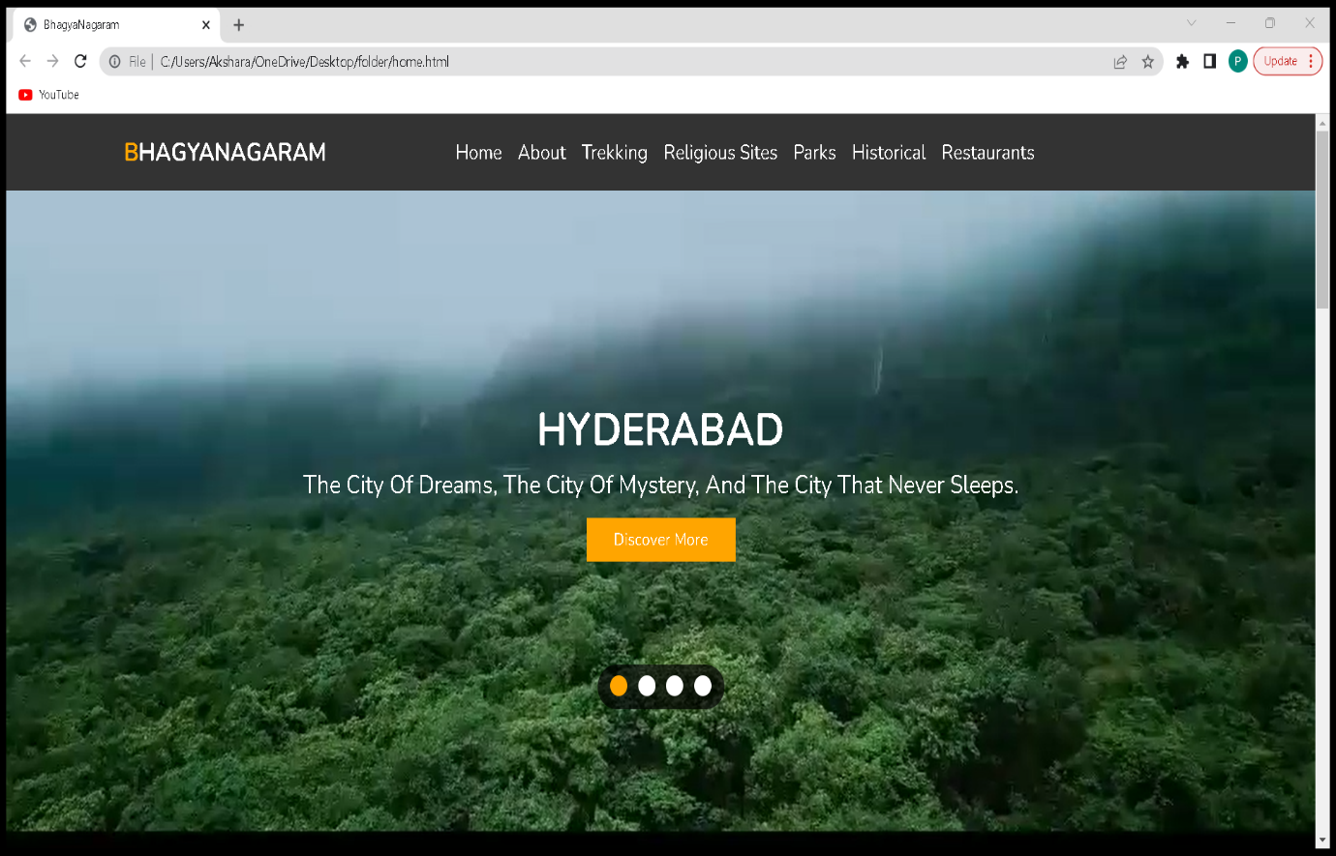

1. The user can then see the gallery, which shows what the site is about to show them.

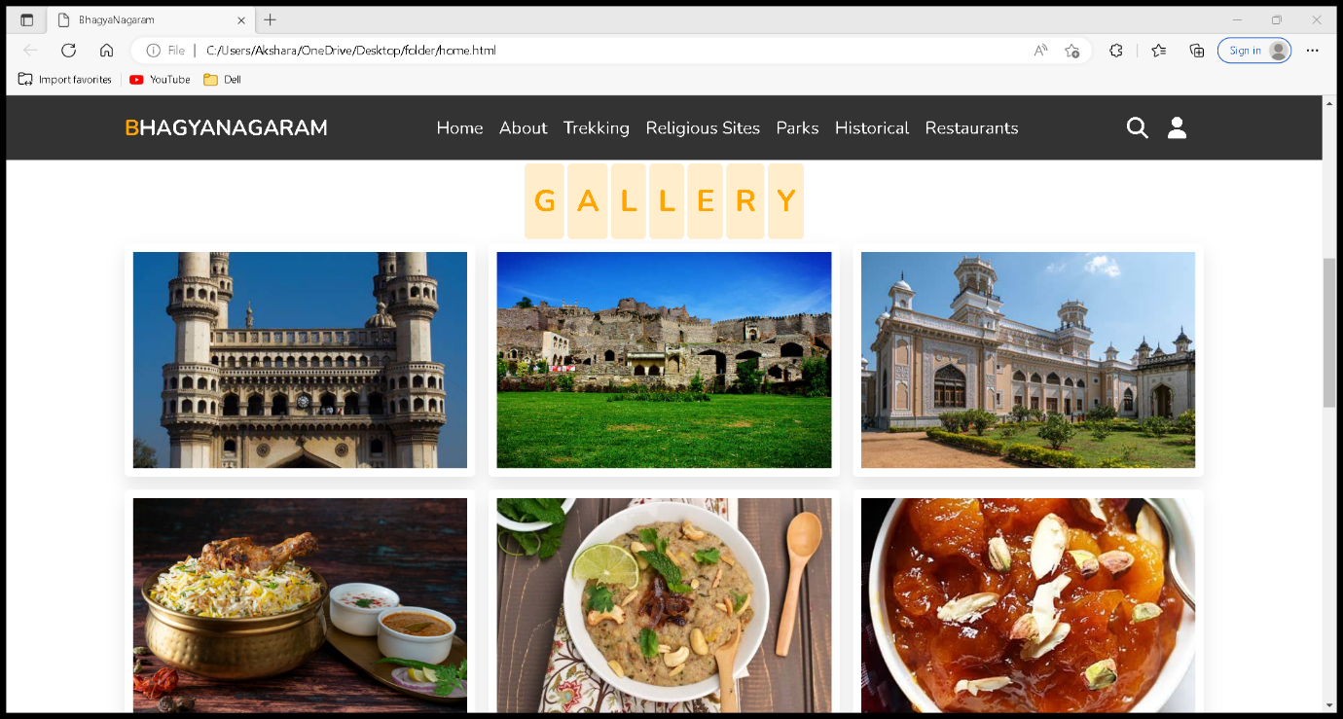

3.The user can give suggestions by filling in the contact details form.

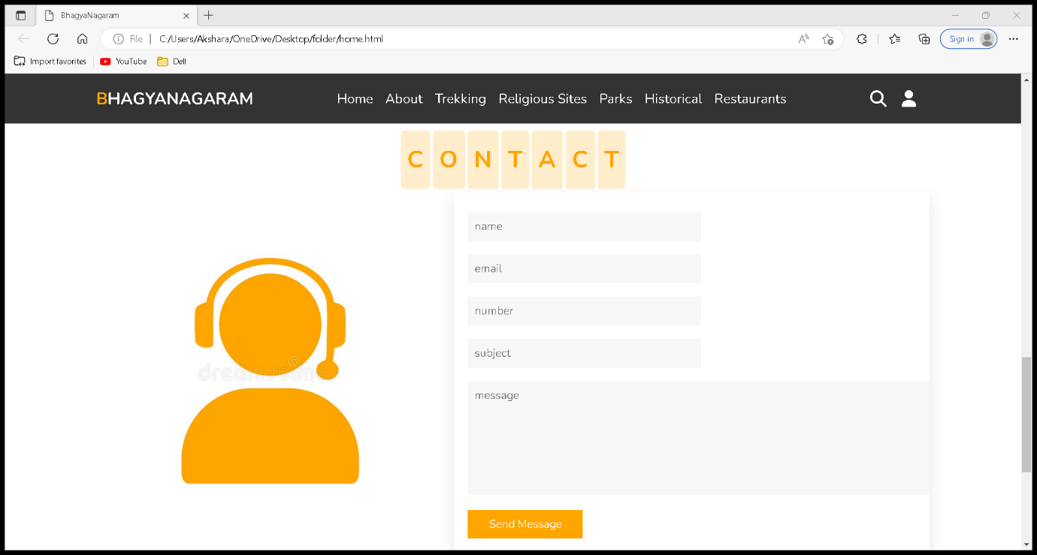

4.The user can now explore the other sub webpages in the website. We have Trekking places, Historical places, Parks and Waterparks, Restaurants and Religious sites.

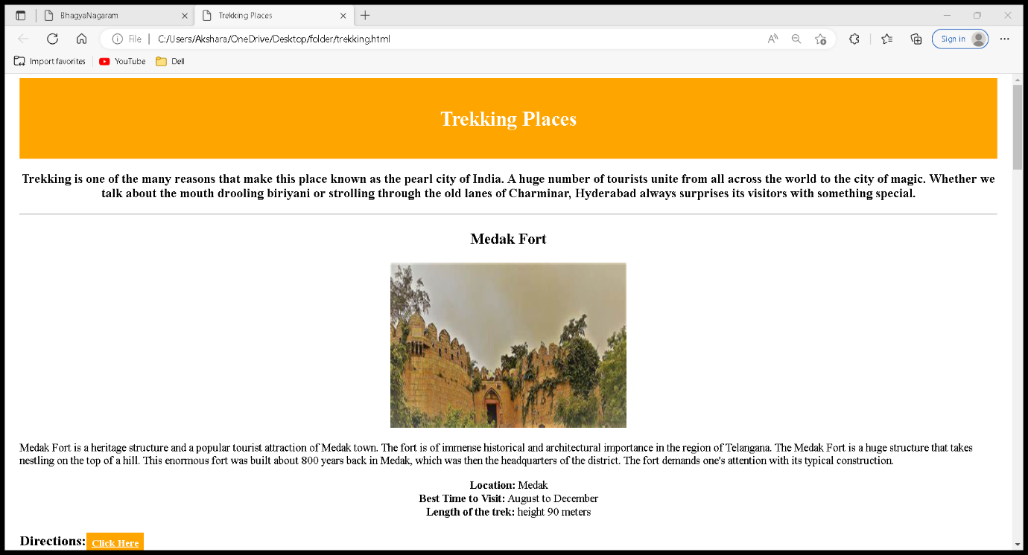

5.If the user wants further details regarding the website information, then the user can login to the website.

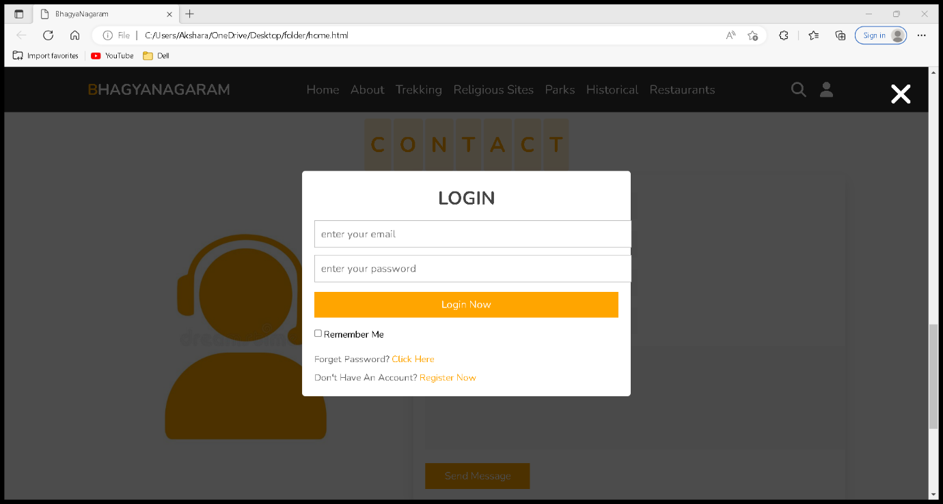

**CONCLUSION:**

As the result the above website is very much informative like other websites we have. With the enhancements that we have proposed, this website could be an alternative for other websites on the internet.

**FUTURE SCOPE:**

We can add more information to the website regarding the places and we can also enhance the website not only within Hyderabad but beyond it. That is we can add details of other states in India as well and we can give information about other states as well. This website can also be developed as an app of tourism places and information regarding it can be given.